**GRAMMAR / VOCABULARY / LISTENING COMPREHENSION**



**UPPER-INTERMEDIATE II - EXTRA ACTIVITIES**

**Teacher: Milena Alonso – mpoalonso@uem.br**

**NAME:_________________________________________________ GROUP:__________________**

Hi Students! These activities revise Vocabulary and Grammar from Unit 2B. Have fun!

**ADJECTIVE ORDER**

|  |  |  |  |  |  |  |  |  |  |
| --- | --- | --- | --- | --- | --- | --- | --- | --- | --- |
| Determiner | Opinion | Size | Age | Shape | Colour | Nationality | Material | Purpose | NOUN |
| A | beautiful | small | antique | square | green | Chinese | porcelain | tea | pot |
| Tree | cute | little |  |  | tabby |  |  |  | kittens |
| An | elegant |  |  | oval |  |  | crystal | salad | bowl |
| A pair of |  |  |  |  | blue |  | denim |  | jeans |
| A | shape |  |  |  |  |  | steel | carving | knife |

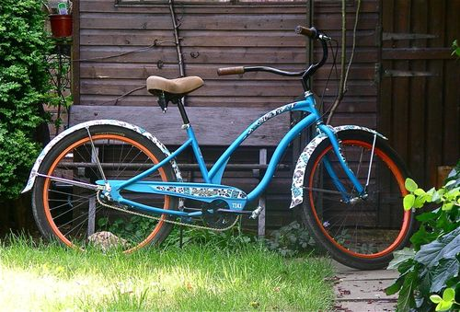**1) Put the adjectives and noun in the correct order; you may need to use a comma if you have multiple adjectives of the same type.**

1. The **blue/old/bicycle** was leaning on the garden shed.

2. She wore a **dress/cotton/red/beautiful** to the picnic.

3. The U.S. President’s office is a(n**) oval/room/large**.

4. Theara grabbed his **plastic/raincoat/old/orange** as he headed out the door.

5. “That’s a really **bamboo/table/lovely/coffee** you have!” Anna said.

6. She bought a **paper/huge/lantern/red/Chinese** for her dorm room.

7. Andy was annoyed when the **Dutch/middle-aged/businessman/important** who was behind him in line got moved to the front.

8. For Father’s Day, Petra got her dad a(n) **leather/comfortable/antique/Italian/black/armchair**.

9. A **little/sad-looking/Labrador/black** puppy sat at the pet store, waiting for someone to pet him.

10. The boy was playing with **some green/pink/marbles/blue/glass**.

11. Mike felt lucky that he had a **nice /bag/sleeping/warm** for camping as he went to sleep that night.

12. “I got this new/eye/glittery/Elizabeth Arden/makeup on sale! Can you believe it?” Taylor exclaimed.

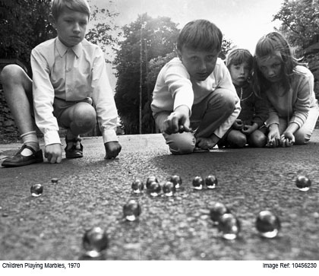

**2) Choose the best option to complete the sentences. Pay attention to the use of adjectives as nouns.**

**1) Governments should do more to help _______________.**

a) the poors b) the poor c) the poorly

**2) We have insufficient health services for _______________.**

a) the elderly b) the elderlies c) the older

**3) ______________ keep getting richer.**

a) The richer b) The richly c) The rich

**4) The government has promised to lower taxes for _______________.**

a) the middle class b) the middle c) the middling class

**5) There is a great stigma around _______________.**

a) the mental ills b) the mentally ills c) the mentally ill

**6) _______________ have been responsible for much of the world's modern philosophy.**

a) The French b) The Frenches c) The Frenchly

**7) We are _______________." (David Bowie, George Orwell, etc.)**

a) the dead b) the deadly c) the death

**8) Did you ever watch _______________?**

a) The Departs b) The Departed c) The Departing

**9) _______________ have less security than those with jobs.**

a) The unemployed b) The unemploy c) The unemploys

**For a list of vocabulary related to clothes, go to the following page. Remember to click on the card twice.**

|  |  |  |  |  |  |  |  |
| --- | --- | --- | --- | --- | --- | --- | --- |
| DETERMINER | OPINION | SIZE/ LENGTH | SHAPE /CUT | COLOUR | PATTERN | MATERIAL | NOUN |
|  |  |  |  |  |  |  |  |
|  |  |  |  |  |  |  |  |
|  |  |  |  |  |  |  |  |

<https://quizlet.com/98781697/clothes-clothing-fashion-b2-fce-upper-intermediate-ielts-band-6-general-english-vocabulary-portalingocom-flash-cards/>

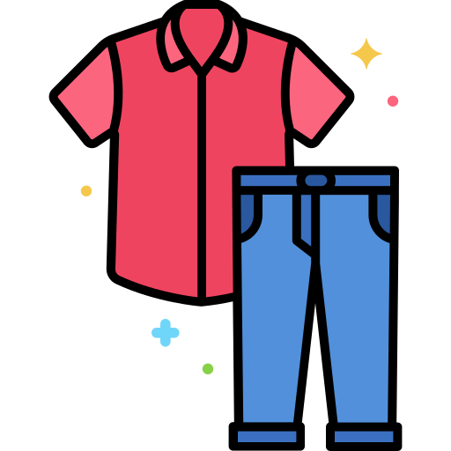

**3) What are they wearing? Use the table to describe their clothes.**

|  |  |  |  |  |  |  |  |
| --- | --- | --- | --- | --- | --- | --- | --- |
| DETERMINER | OPINION | SIZE/ LENGTH | SHAPE /CUT | COLOUR | PATTERN | MATERIAL | NOUN |
|  |  |  |  |  |  |  |  |
|  |  |  |  |  |  |  |  |
|  |  |  |  |  |  |  |  |

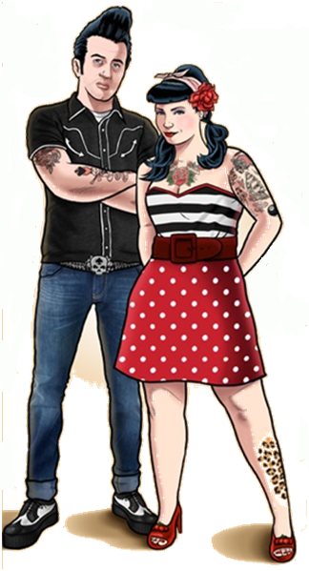

**The womanis wearing…**

**The man is wearing…**

**4) Complete the 15 sentences with the words on the left.**

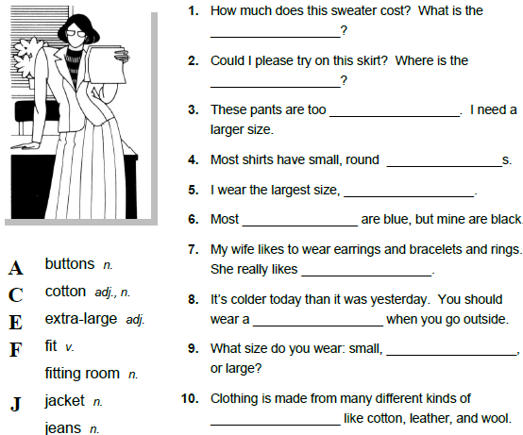

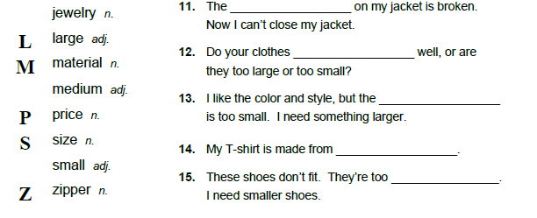

**5) Listen to the audio and number the pictures from 1 to 12. Number 1 is already done for you.**



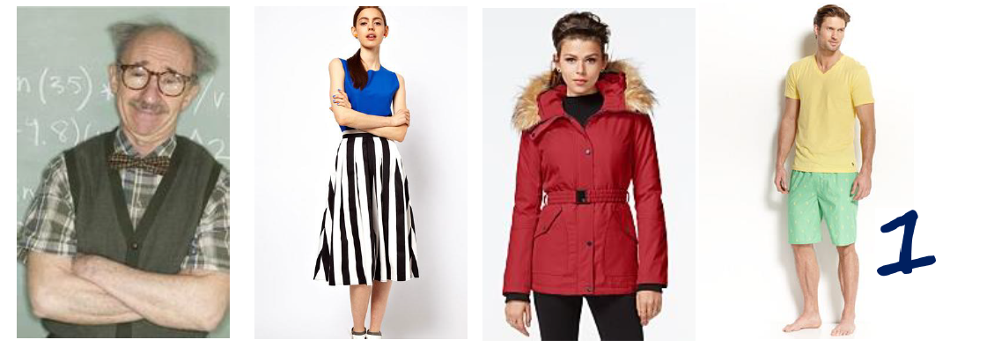

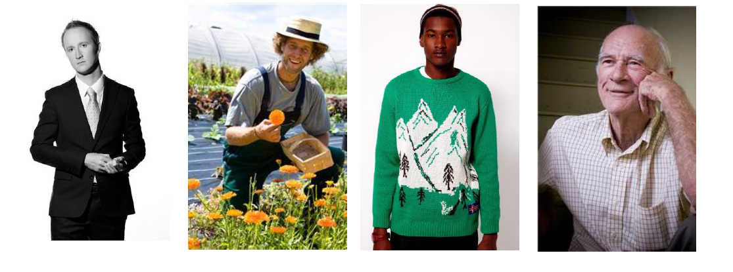

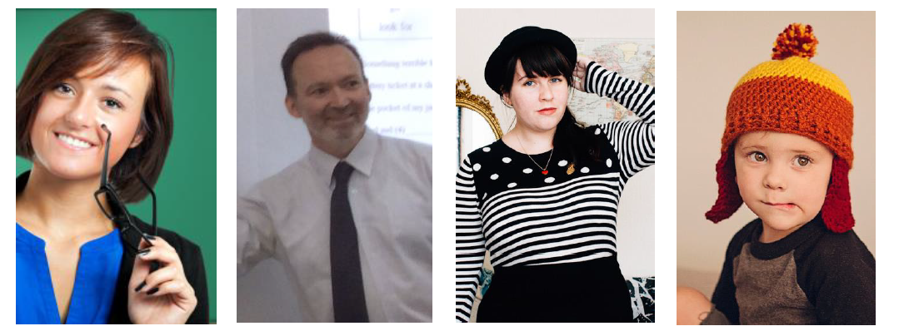

**For extra listening practice, click on the following link to watch some news related to fashion:**

<https://tv-english.club/ectv-news-episodes/episode-11-03-2016/>



**ANSWER KEY**

**Exercise 1**

1. old blue bicycle

2. beautiful red cotton dress

3. large oval room

4. old orange plastic raincoat

5. lovely bamboo coffee table

6. huge red Chinese paper lantern

7. important, middle-aged Dutch businessman

8. comfortable, antique black Italian leather armchair

9. sad-looking, little black Labrador puppy

10. green, pink, and blue glass marbles

11. nice, warm sleeping bag

12. glittery new Elizabeth Arden eye makeup

**Exercise 2**

1. b)

2. a)

3. c)

4. a)

5. c)

6. a)

7. a)

8. b)

9. a)

**Exercise 4**

1. price

2. fitting room

3. small

4. buttons

5. extra-large

6. jeans

7. jewelry

8. jacket

9. medium

10. material

11. zipper

12. fit

13. size

14. cotton

15. large

**Exercise 5**

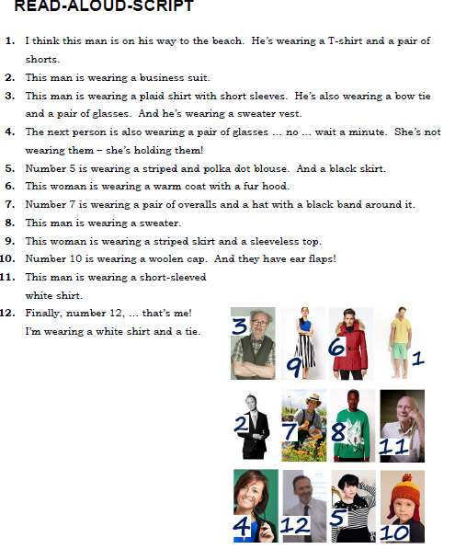

**Please send a copy of the exercises to the teacher´s e-mail. Hope you enjoy guys!**